DocSpot – Seamless Appointment Booking for Health
Team Members:
TEAM ID : LTVIP2026TMIDS65846
MEMBER | RESPONSIBILITY
1. Yalakaturi Narendra | Testing &Documentation
2. Gadde Maha Ganesh | Resource Gathering
3. Bandalapati Vamsi Vardhan | Resource Gathering
4. Battula Kalyani | Frontend , Backend & Database

1. Introduction
Project Title:
DocSpot – Seamless Appointment Booking for Health
2. Project Overview
Purpose:
DocSpot is a full-stack web application designed to streamline the process of booking medical appointments between patients and healthcare providers. The goal is to eliminate the traditional hassles of calling clinics or waiting on hold by offering a user-friendly digital platform where users can register, browse doctors, book, manage, and confirm appointments online.
Features:
- User registration and login (Patients & Doctors)
- Browse and filter doctors by specialty, location, availability
- Book appointments with date selection and document upload
- Real-time appointment status updates
- Doctor dashboard for managing schedules
- Admin panel for approving doctors and monitoring activity
- Email/SMS notifications for confirmation and reminders
- Post-visit follow-up summaries and prescriptions

3. Architecture
Frontend:
Built using React.js , the frontend follows a component-based architecture:
- Component Structure: Functional components with hooks (useState, useEffect)
- Routing: React Router v6 for navigation
- State Management: Context API for global state (user auth, appointments)
- UI Library: Material-UI for responsive design
- HTTP Requests: Axios for API calls
Backend:
The backend is built using Node.js and Express.js :
- RESTful API endpoints
- Middleware: cors, dotenv, morgan, express-validator
- Authentication: JWT middleware for protected routes
- Modular structure: Routes, Controllers, Models
Database:
MongoDB (NoSQL) is used with Mongoose ORM.
4. Setup Instructions
Prerequisites:
Ensure you have the following installed:
Node.js (v16.x or higher)
npm or yarn
MongoDB Atlas account or local MongoDB instance
Git
Installation Steps:
- Clone the repository
git clone https://github.com/YalakaturiNarendra/DocSpot-MERN
cd docspot
- Set up environment variables:
Create .env file in the server directory
PORT=5000
MONGO_URI=mongodb://localhost:27017/docspot
JWT_SECRET=mysecretpassword
- Install dependencies :
Backend
cd server
npm install
#Frontend
cd ../client
npm install
Folder Structure
Client:
/client
├── public/
├── src/
│ ├── components/
│ │ ├── DoctorList.jsx
│ │ ├── AppointmentForm.jsx
│ │ └── Navbar.jsx
│ ├── context/
│ │ └── AuthContext.js
│ ├── pages/
│ │ ├── Home.jsx
│ │ ├── Login.jsx
│ │ ├── Register.jsx
│ │ └── Dashboard.jsx
│ ├── App.js
│ └── index.js
└── package.json
SERVER:
/server
├── controllers/
│ ├── userController.js
│ └── appointmentController.js
├── models/
│ ├── User.js
│ └── Appointment.js
├── routes/
│ ├── userRoutes.js
│ └── appointmentRoutes.js
├── middleware/
│ └── authMiddleware.js
├── config/
│ └── db.js
├── .env
├── app.js
└── package.json
6. Running the Application
To start both servers:
Frontend:
Navigate to the client directory:
cd client
Start the development server:
npm start
The frontend application runs on: http://localhost:3000
Backend:
Navigate to the server directory:
cd server
Start the backend server:
npm start
The backend application runs on: http://localhost:5000
7. API Documentation
Base URL:
http://localhost:5000/api
Auth Endpoints:
POST /auth/register
Registers a new user (patient or doctor) with name, email, password, and role.
POST /auth/login
Logs in a registered user and returns a JWT token for authentication.
Appointment Endpoints:
GET /appointments (Protected)
Retrieves all appointments for the logged-in user.
POST /appointments (Protected)
Creates a new appointment with selected doctor, date, reason, and optional documents.
PUT /appointments/:id/status (Protected)
Updates the status of an existing appointment (e.g., confirmed, cancelled).
DELETE /appointments/:id (Protected)
Deletes an appointment by its ID.
User Endpoints:
GET /users/doctors (Protected)
Returns a list of available doctors for booking.
GET /users/me (Protected)
Returns the profile information of the currently logged-in user.
8. Authentication
Authentication is handled using JWT (JSON Web Tokens) :
Upon successful login, the system generates a JWT token.
This token is stored in the browser's localStorage.
All protected routes require a valid token for access.
Middleware verifies the token and authorizes access based on user roles: patient, doctor, or admin.
9. Screenshots or Demo
HOME PAGE :
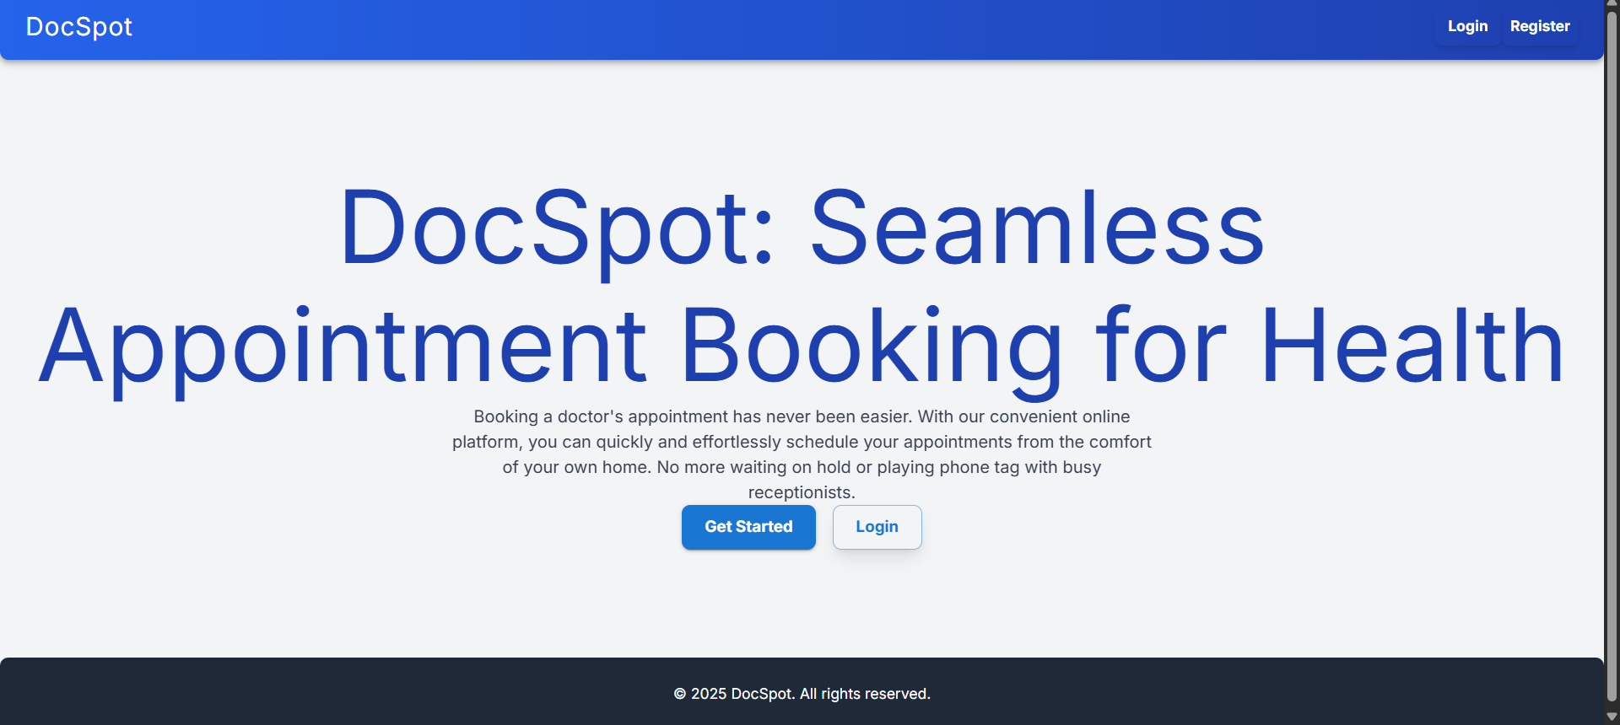 LOGIN PAGE:
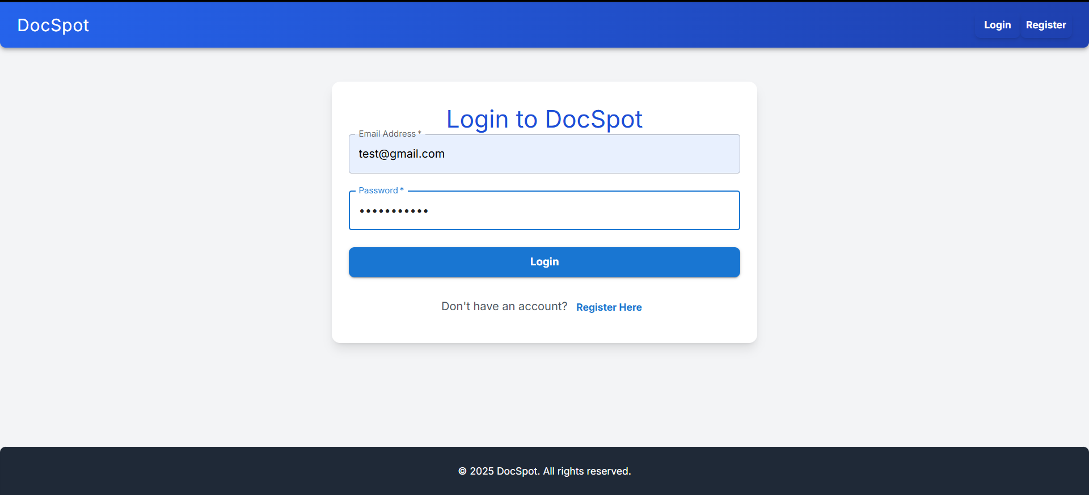

REGISTER PAGE :
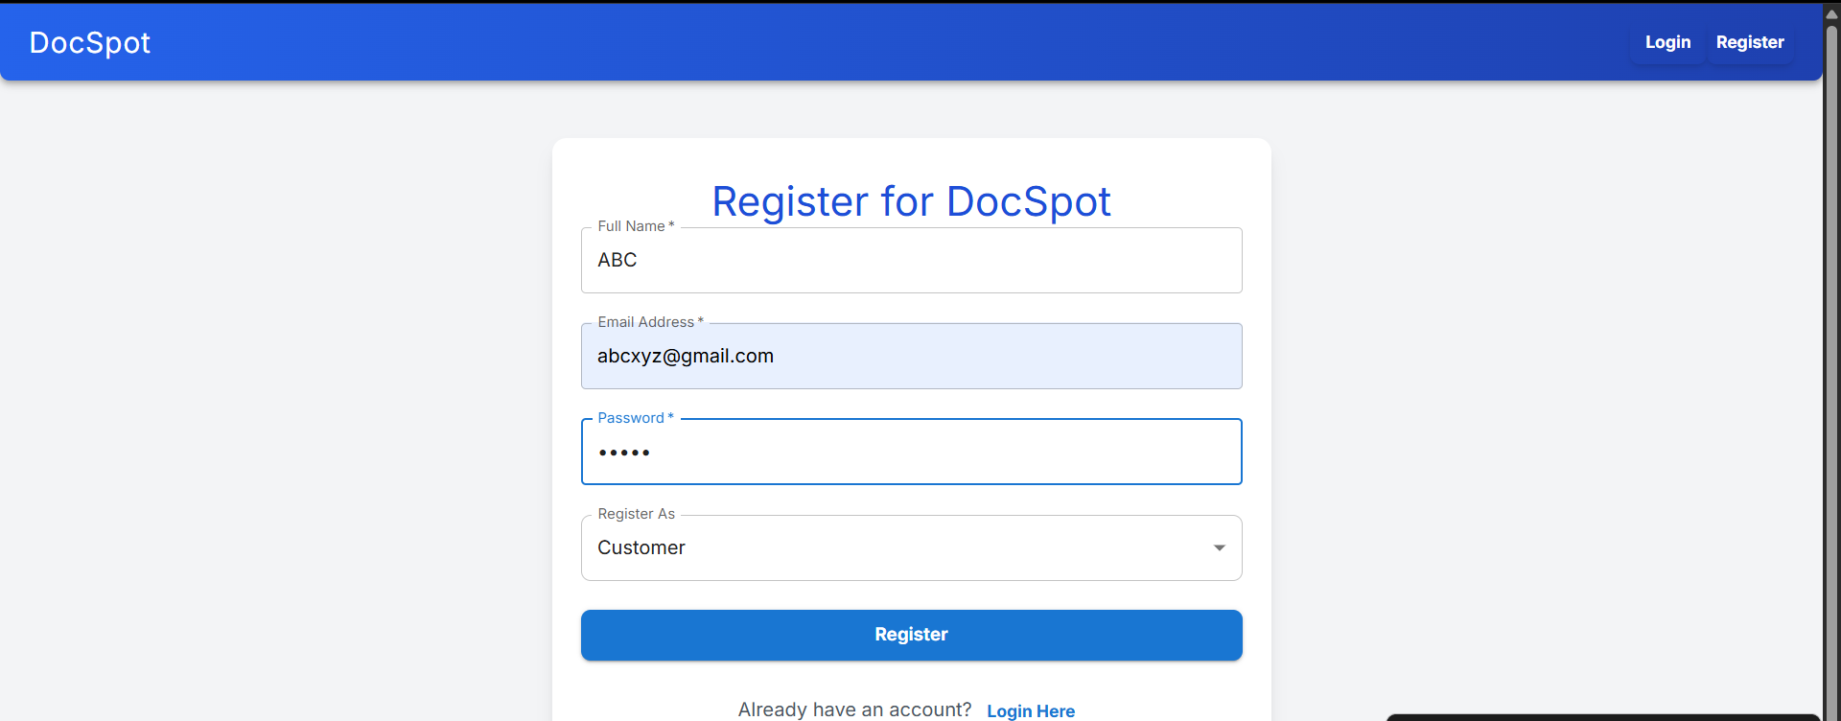 DASHBOARD:
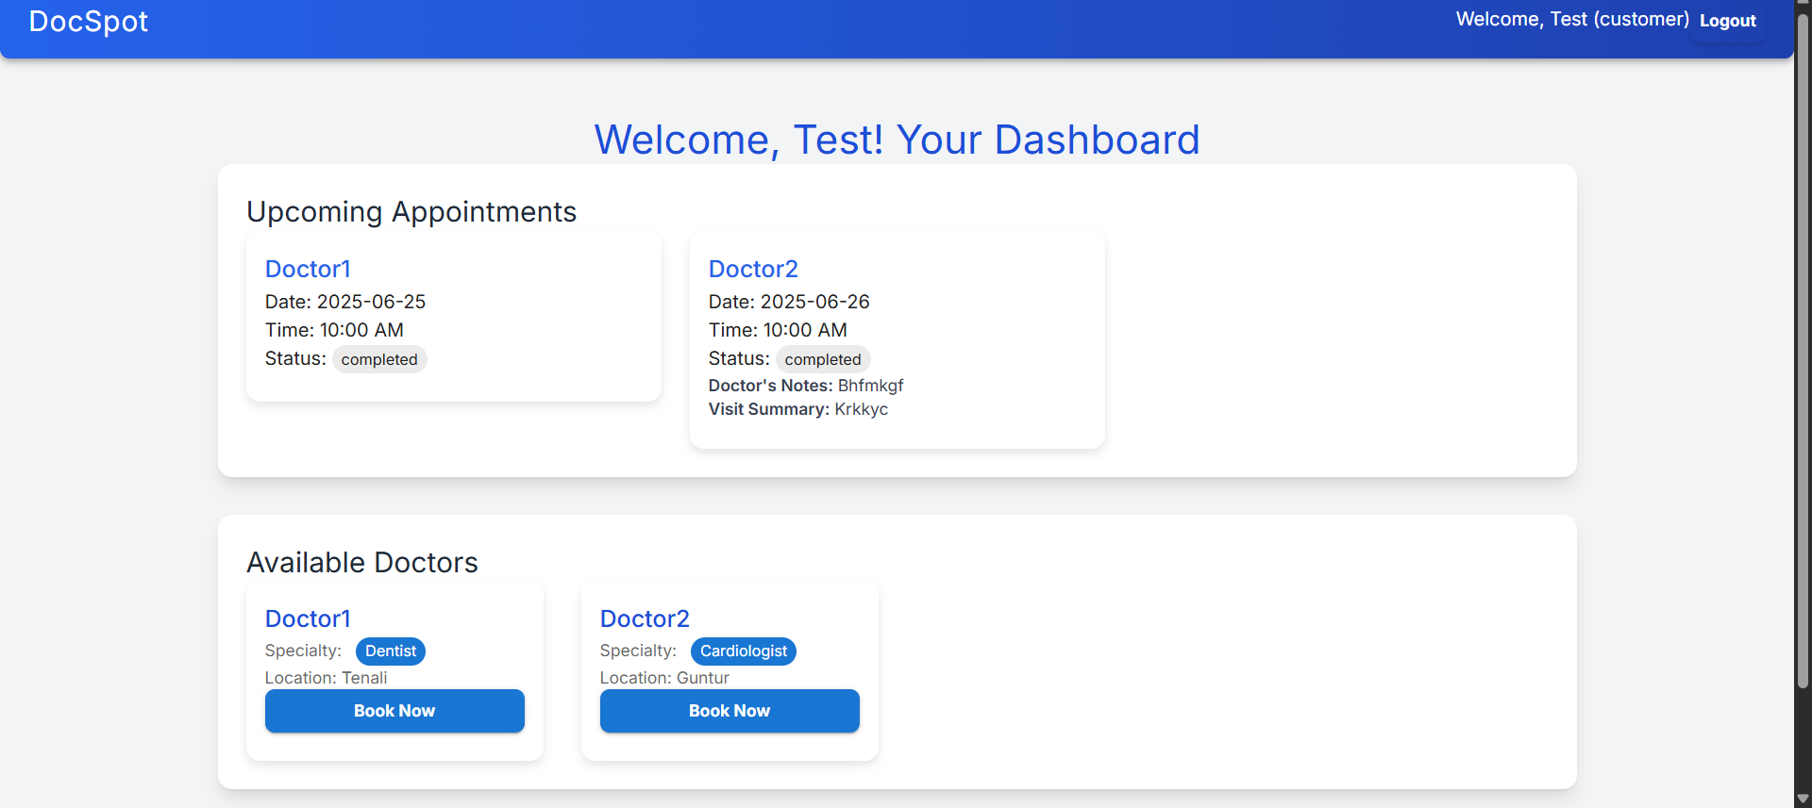
10. Testing
Testing Strategy:
Frontend components are tested using Jest and React Testing Library.
Backend APIs are tested using Mocha and Chai for validation of responses and error handling.
End-to-end testing is performed using Cypress to simulate real-user interactions.
11. Known Issues
The appointment status may not update instantly without manually refreshing the page.
Document upload functionality currently supports only PDF file types.
The admin approval workflow requires manual triggering in some deployment environments.
Dashboard tables have limited responsiveness on mobile devices.
12. Future Enhancements
Integrate video consultation features for telehealth services.
Allow patients to rate and review doctors after appointments.
Implement an AI-based symptom checker for better doctor recommendations.
Sync appointments with external calendars like Google Calendar for reminders.
Add multi-language support to cater to diverse users.
Provide assistance with insurance claims directly through the app.

